In 1980 on Skinwalker Ranch I was visited by a silver bowl-shaped craft and “zapped” by a Non-Human Intelligent being. This caused me to reluctantly become a life-long part of The Phenomena itself, like many of us here. I’m sharing my story now to encourage other Experiencers to share, provide mutual support and help us figure out the nature and purpose of what’s happening to us and the world today.

Before I start, a loving reminder:

The Sheep-Goat effect is in full force here! I’m posting this for you, the real Experiencers on r/experiencers, to help unite us in friendship, support and common-ground.

If you are a non-Experiencer and think this and we are “all bullshit” then just downvote me and move on. Don’t waste the Mod’s time here posting things against the rules of the forum, which will just get you removed.

If you’re truly seeking to understand what I’m about to share share what I think about The Paranormal, I suggest you explore the scientific investigations into Near-Death Experiences and binge-watch The Secret of Skinwalker Ranch.

Episode 1: The King and a Boy Named Dean - How I lost my Paranormal Virginity on Skinwalker Ranch in 1980

Once upon a time, in the summer of 1980, there was a horse named King and an 11-year old boy named Dean. That’s me.

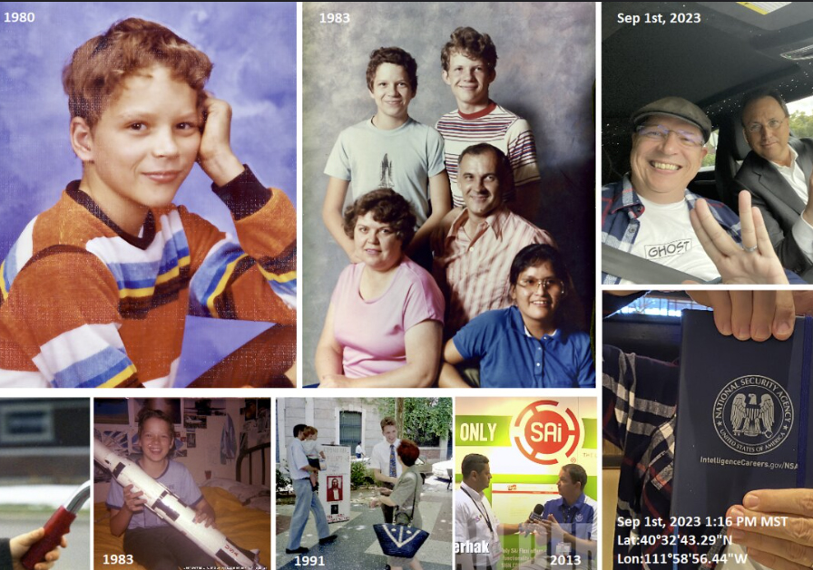

My adventure into the so-called “paranormal unknown” started as I settled onto the saddle atop King, a large and beautifully brown horse that lived on my Uncle Grant’s farm in the Uintah Basin, Utah. My mother and brother were there that week visiting with my uncle, Aunt Jennis and my cousins, far away from Salt Lake City where we lived.

That summer morning it was my turn to ride King alone anywhere on the farm he would take me. I loved riding with him across the tall hay fields and through the grazing cows, with the unforgettably majestic backdrop of the red-rock mesa nearby.

For the first time, out of curiosity, we rode out to the northwest end of the farm, mostly to see the old rusty cars and abandoned farm equipment scattered along the north border tree line.

Back in 1980, no one could have even imagined that 14 years later, the adjacent property within a rocks-throw of me would laker become the infamous Paranomral Disneyland when it was purchased by The Sherman Family in 1994. Nor could I have anticipated that my name would be associated with it from the very first news article on up until right now, with you reading my story here.

At age 11, I’d never heard the word “Skinwalker” before, and few people had, because it was apparently a secret back in 1980 and the “White Folks” weren’t supposed to say it. As for the local Native-Americans, the word was forbidden and feared. They told their children that saying the word risked inviting a Skinwalker or friends-of-the-Skinwalker into their lives - especially at night. Today, Brandon Fugal owns the trademark on the terms Skinwalker and Skinwalker Ranch.

Back then I also didn’t know anything about the farmland or people homesteading around my Uncle Grant’s farm. And although my mother had been born in the Uintah Basin, back then there was little talk of the UFOs shining in the night - just spooky stories of ghosts haunting the nearby towns.

So it was just another normal sunny day for King and I, as we reached and meandered along the far-north tree line at the end of a hay field, passing the rusty old farm gear and heading east.

As we approached the northeast corner of the farm, I suddenly noticed the smell of sweet maple syrup, pancakes and bacon (like a breakfast). That smell seemed to draw me in for a closer look, past the end of some trees.

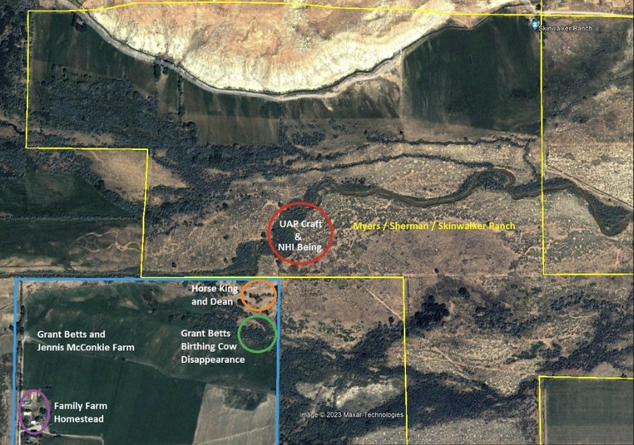

Then a large silver dome-like object came into view. It was a shiny silver/chrome UAP craft in appearance, about 30 to 40 feet wide and was shaped like a bowl upside down and slightly above the ground. Since I was sitting up on King’s back at the time, I was uncertain of our distance from the craft, but it appeared to be landed to the east of us, close and near the winding southern gulch on SWR.

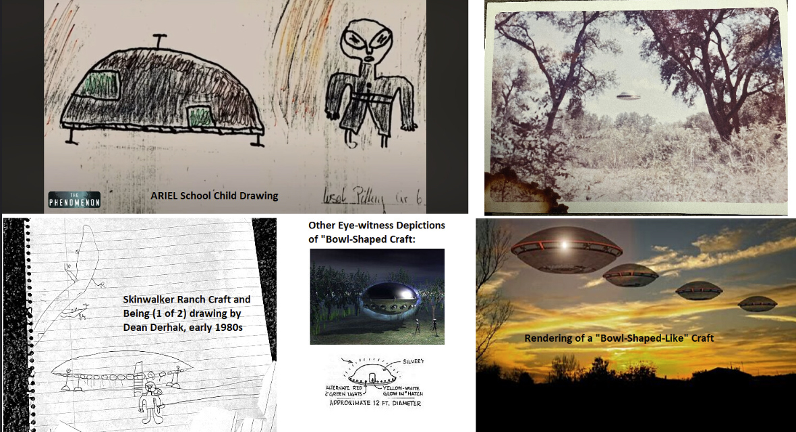

Standing close to the silver bowl-shaped craft was a Non-Human Intelligent Being of humanoid shape, approximately 4-5 feet tall, wearing a matte silver/white suit with a head cover/helmet similar-looking to a hazmat suit. I did not observe any eyes. However, the being did move oddly, in a non-normal human manner.

At first sight, the Being was kneeling and looking down at the ground, holding a some kind of object. The Being didn't seem to notice us at first, but quickly stood up and looked right at us. When the Being saw us staring, it paused and then pointed what then appeared to be some kind of a gun. This startled me, but King remained calm, looking right at the Being’s direction.

Suddenly, the Being flashed us with a blinding-bright colored light several times. I became dazed while King remained steady as I sat teetering on his back.

As I was still dazed and disoriented, the Being immediately entered the craft (which I did not witness) and then the craft lifted off in a matter of seconds. I watched as it shot off into the sky as it flew closely and directly over the redrock Skinwalker Ranch mesa, in complete silence.

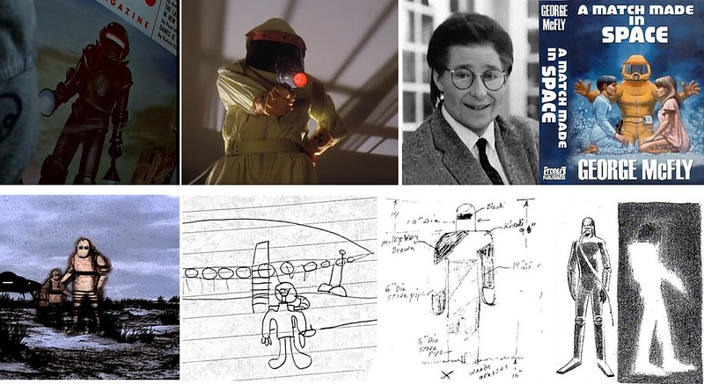

The craft’s speed and direction were very similar to what Skinwalker Ranch owner, Brandon Fugal eye-witnessed during his saucer-shaped encounter over the Ranch mesa in 2016.

This entire close encounter with King seemed to last only several minutes at the most. As soon as the craft was gone, I felt scared, wondering WTF had just happened to us and where we were.

Although King continued to be calm, I panicked and quickly brought him to a full gallop, rushing across the hay fields. Terrified, I made it to the homestead coral, where I could give King a rest and keep myself from peeing my pants from Ontological Shock.

I’ll explain the immediate aftermath in my next episode post. But for now, understand that within days after this first paranormal experience, my mind was clouded about what had actually happened that afternoon. Apparently, I was now in good company.

As you fellow Experieners know, once you’ve had that first experience with The Collective Paranormal, there’s no going back. You’ve become part of The Phenomena itself. For me, this has included decades of profound synchronicities, unexpectedly vivid precognitive dreams, and invaluable spiritual insights about eternal progression. All of which I’ll be sharing in the near future here.

And yes, I’m experiencing on-going communion with the Super-Intelligent Non-Human Intelligences headquartered on and in the Uintah Basin area of Skinwalker Ranch, just like others including Chris Bartel, Ryan Skinner and many more. Apparently, feeling strongly “Called the Skinwalker Ranch” is a real thing for some people.

Truth be told, I have strongly resisted and avoided most of the steps on my personal path, until I found myself this September bearing my soul to Brandon Fugal during one of our lunches. This led to me sobbing with my mother, for the first time since I was that little kid, and at age 54 remembering it all again for what seemed like the first time. I knew it was time to finally go public with my story here.

For those of you who don’t know about Skinwalker Ranch, or haven’t figured out yet that it’s ground-zero for Global Human Full-Disclosure and First Contact, welcome to what I think is the real world.

I encourage you to wake up and look at the stars tonight. If I’m right, you’ll begin to understand what to do. The next step is yours!

